**Contract Management System**

**Problem Breakdown:**

1. Find key features
   * Add Contact
   * View Contacts
   * Remove Contact
   * Search Contact
   * Exit
2. File structure(module):
   * Contract Management System
     + Main.py
     + Add_contract.py
     + View_contract.py
     + Remove_contract.py
     + Search_contract.py
     + Data_storage.py
3. Define function
4. Implement logic

* Import different function
* Take input
* Checked invalid input
* Error handling

1. Run and test all functionality.

**Flow Chart:** 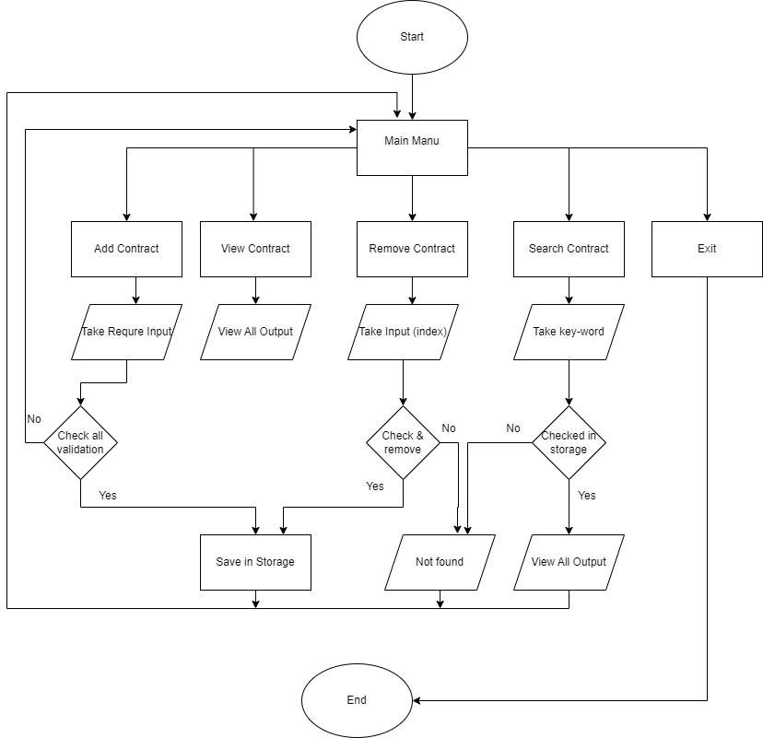

**Completed Features:**

Add Contacts---> with validation

View Contacts ---> Tabular

Save to File ---> CSV

Load from File ---> from CSV with previous value.

Remove Contacts ---> with index number

**BONUS FEATURES:**

Search Contacts ---> with key-word

Error Handling ---> name string,

Phone number integer.

NOTES:

File Structure ----> multiple Python files with functionality.

Application Design ---> Flow Chart

Modular Code ---> reusable

No External Libraries ---> not used

Menu System ---> main menu with exit.

**.**